**MULTIPLE DATABASES DJANGO:**

IN ORDER TO ACHIEVE OUR GOAL, WE MUST MODIFY OUR ***settings.py*** FILE ***models.py*** FILE AND ADD ***router.py*** FILE:

1. ***settings.py***

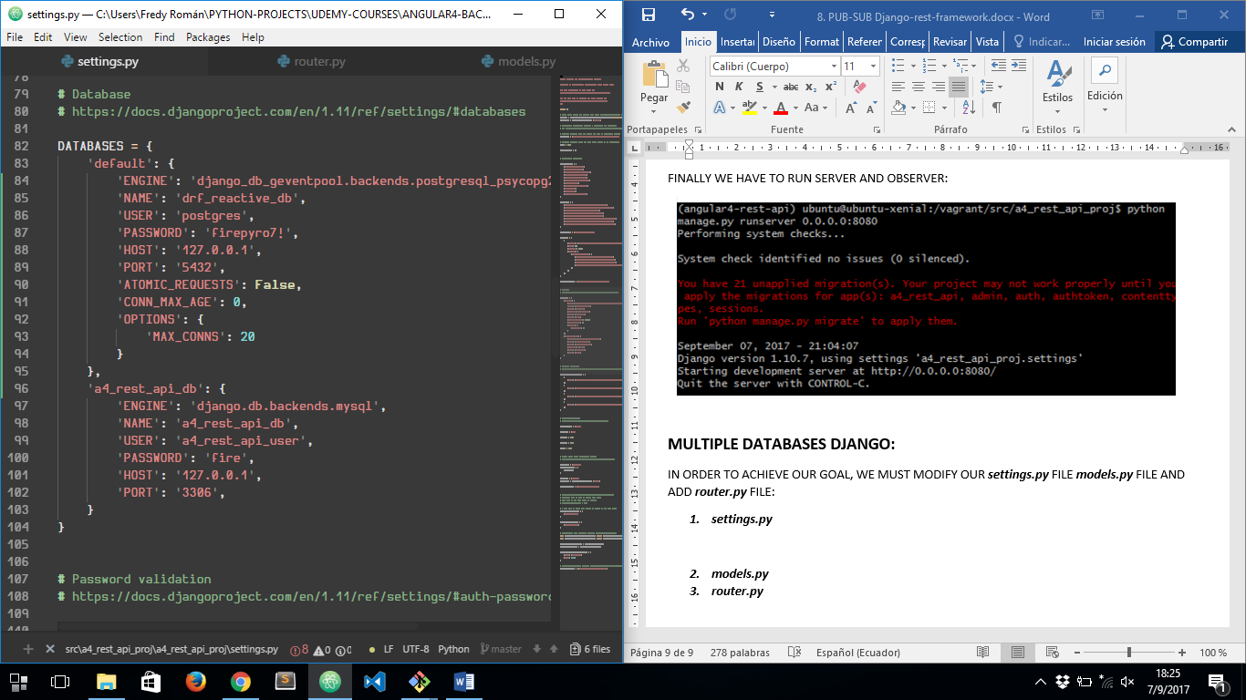

1. ***models.py***

WE HAVE TO SPECIFY DJANGO APP NAME INSIDE EACH MODEL CLASS:

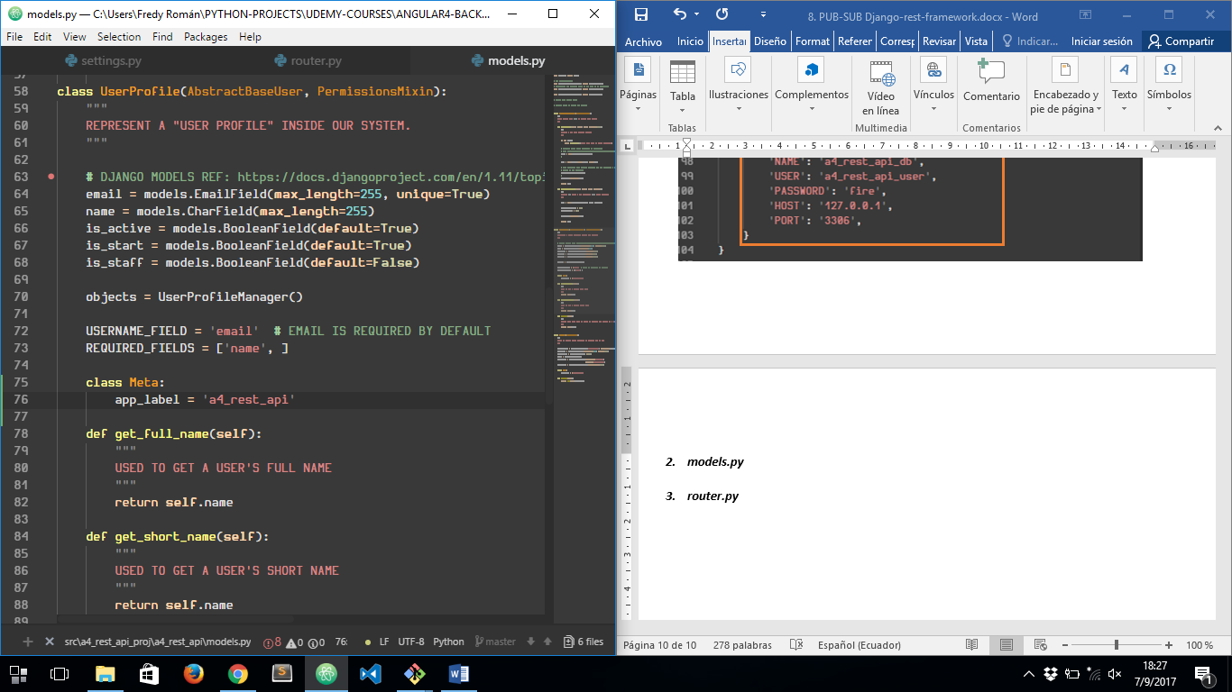

1. ***router.py***

NOW WE HAVE TO CREATE THIS FILE INSIDE OUR DJANGO APP AND ADD NEXT CODE:

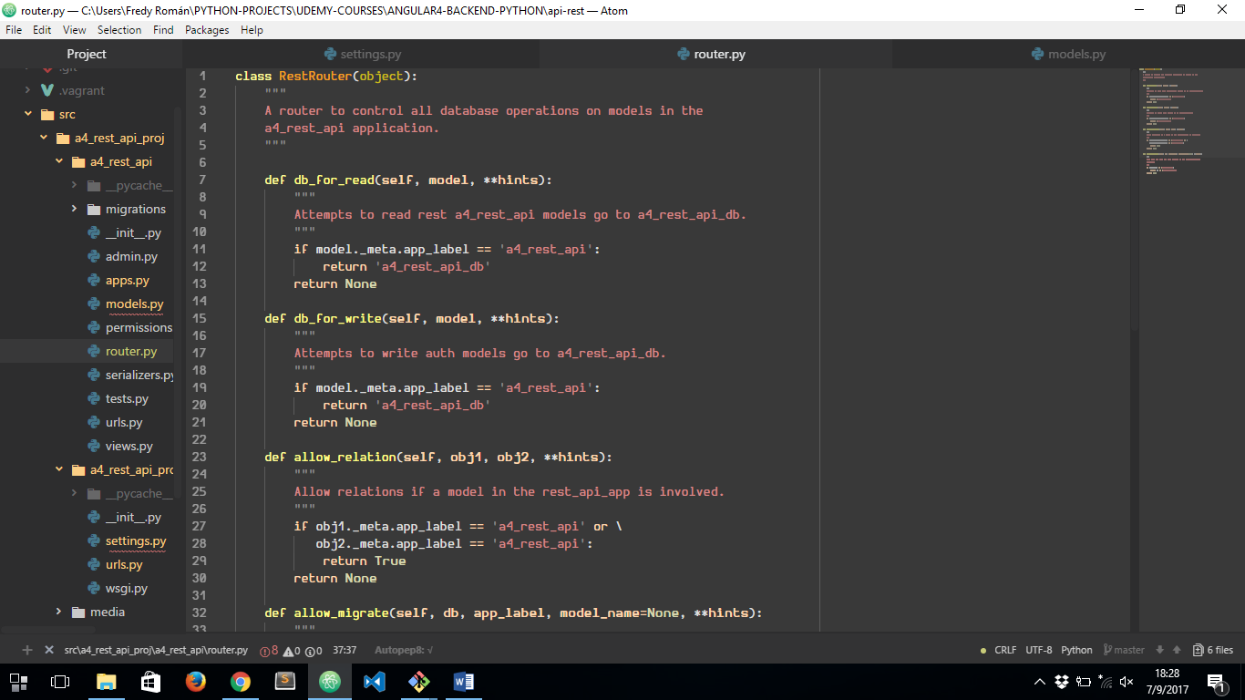

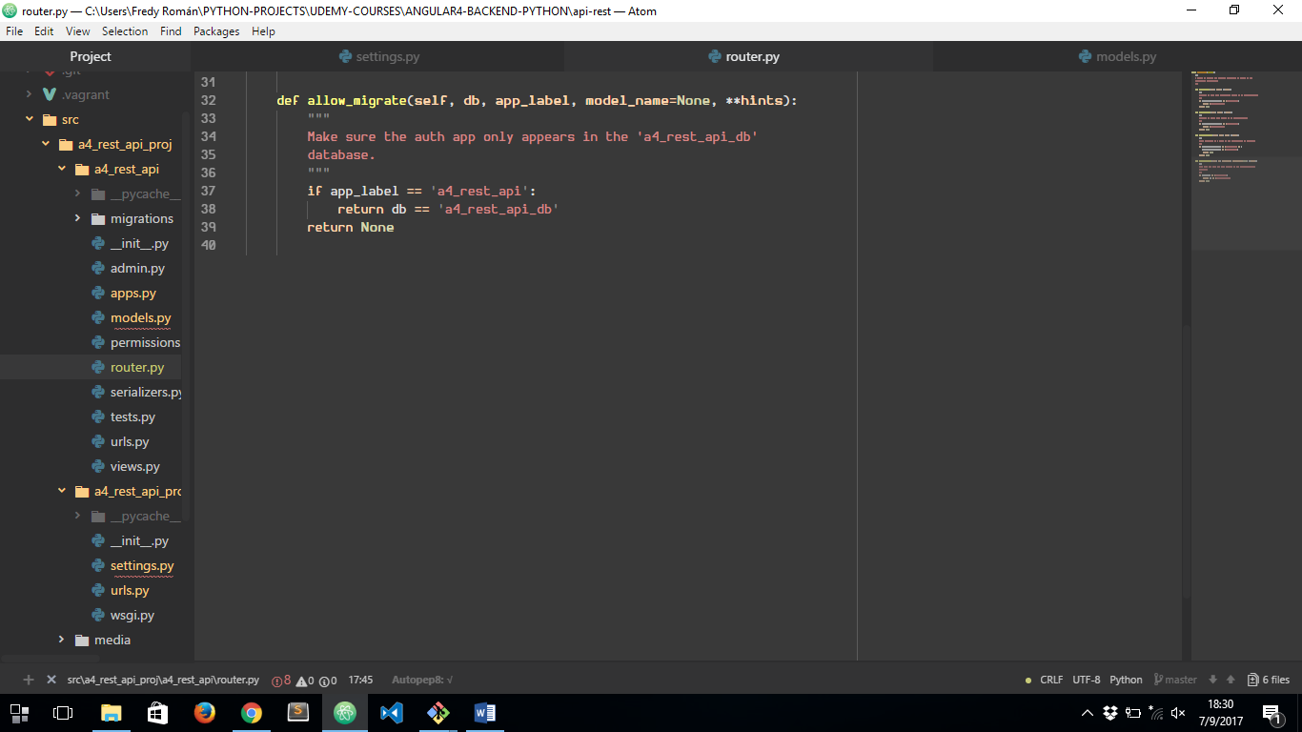

CODE TAKEN FROM:

<https://docs.djangoproject.com/en/1.11/topics/db/multi-db/>

FINALLY WE HAVE TO ADD NEXT LINE AT THE END OF ***settings.py***

